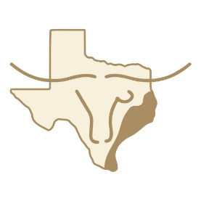
TEXAS LONGHORN BREEDERS GULF COAST ASSOCIATION
2026 TLBGCA Spring Show
World Qualifying Youth Shows (Standards & Miniatures)
World Qualify Open Haltered Shows (Standards & Miniatures)
Trophy Steer Show (Haltered)
(note: there will not be a Non-Haltered show)

May 1st-3rd, 2026
Grimes County Fairground
5220 FM 3455, Navasota, TX 77868

Entry Fees: Youth Points Only show (Friday) $25.00
Youth show (Saturday) $45.00
Open show (Sunday) $45.00
Late fee (after 4/19/26) $10.00 per entry
Prizes and Buckles for Youth Show. Buckles and Premiums for Open Show. Only pellet bedding allowed. No shavings. Their will be a $100 fee charged if any exhibitor puts down shavings.
Schedule of Events

Friday, May 1st 2026
12:00 PM Begin checking in cattle, continuing all day (Do NOT arrive early)
5:30 PM Youth Points-Only show Judge: Scott Jones

Saturday, May 2nd 2026
9:30 AM Youth show Judge: John Oliver

The 2025 donation calves will show immediately following showmanship and the winning calf will receive a buckle for the donor of that calf. After the Youth Show will be the 2026 Scholarship Awards (In the Ring), Donation Calf Drawing and a TLBT Social for everyone

Sunday, May 3rd 2026
9:00 AM Cowboy Church Message:
9:30 AM Open Haltered Show Judge: Russell Fairchild

